**Invasion of the body snatchers: Parasites alter behaviour and morphology of an invasive snail**

Em G Lim1, Colin MacLeod1, Brianna Heese3, and Christopher DG Harley1,2

1. Department of Zoology, University of British Columbia, Vancouver, BC, Canada

2. Institute for the Oceans and Fisheries, University of British Columbia, Vancouver, BC, Canada

3. Vancouver Island University

Corresponding author: EG Lim, emily.lim13@gmail.com

Present addresses:

**Keywords**

**Abstract**

Introduced species often display altered behaviour in new environments, but the extent to which interactions are maintained when two interacting species are introduced together is unknown. We investigated an invasive host-parasite pair in a novel habitat to examine how behavioural and morphological control of the host by the parasite varies between these species’ native and introduced ranges. We found that Japanese mud snails (*Batillaria attramentaria*) infected with trematode parasites (*Cercaria batillaria*) were more likely to be found lower in the intertidal at 9 of 10 beaches we surveyed in the Salish Sea, but at one site, Page Lagoon, this trend was reversed. Our in situ growth rate experiment revealed that infected snails grow faster and reach a larger maximum size than uninfected snails. Infected snails also moved toward the lower intertidal at 2 of the 3 beaches where we marked them, but again this trend was reversed at Page Lagoon. These morphological and behavioural effects are assumed to increase parasite reproduction and transmission, and extend the range of Japanese mud snails into the lower intertidal. Further, reversed trends in lagoon snails hint at an effect of salinity on infected snail behaviour, as salinity-driven currents differ between Page Lagoon and the other sites. Our results are largely in line with similar studies from the native range of Japanese mud snails, but opposite trends at Page Lagoon reveal the effect environmental conditions can have on parasite-controlled behaviour.

**Introduction**

Introduced species often display altered behaviour in new environments (Ross, Vargo & Keller, 1996; Suarez et al., 1999; Meyer & Dierking, 2011), but predicting behavioural shifts is complicated when interacting species are introduced together (Zukl, Simmons & Cupp, 1993; Goedknegt et al., 2016). As invasive species threaten global biodiversity, predicting these potential behavioural shifts are of the utmost importance (Holway & Suarez, 1999). Parasites are known to have broad impact on their hosts, often altering host behaviour in order to successfully infect the next host and complete their lifecycle (Poulin, 2010). For example, trematode parasites will encyst in the foot of bivalves, leaving them unable to burrow into the sediment and avoid their predators, which act as tertiary hosts (Mouritsen, 2002, 2004).

One such host-parasite pair is the Japanese mud snail (*Batillaria attramentaria*), which is infected by 8 morphologically distinct parasite species in its native range, but only one (*Cercaria batillaria)* in its invaded range of North America (Miura et al., 2006b). The Japanese mud snail was introduced to the Pacific Northwest in the early 1900s with Pacific oysters, likely hiding in the seaweed used to pack oysters intended for aquaculture (Barrett, 1963; Miura et al., 2006b). This invasive snail is threatening biodiversity in California (Byers & Goldwasser, 2001; Torchin, Byers & Huspeni, 2005), but has paradoxically been found to bolster biodiversity in the more northern Washington (Wonham, O’Connor & Harley, 2005). In British Columbia, Canada, this invader doesn’t seem to be displacing any native species, but given the impressive densities this snail reaches, ecological impacts are highly likely.

In the native range of Japan, *C. batillaria* infection castrates host snails, as energy is reallocated away from reproduction instead towards somatic growth (Miura et al., 2006a). Infection also alters host behaviour, with infected snails occurring deeper in the intertidal zone than uninfected snails, presumably to increase transmission to the next host - a fish (Miura & Chiba, 2007). We set out to determine whether these interactions are maintained when the host snail is introduced to a novel environment with only one of the eight parasites that infect it in its native range. We surveyed snail position, density, size, and parasite infection at 10 beaches in the Salish Sea, and conducted mark-recapture experiments at 3 beaches to characterize the effect *C. batillaria* has on the behaviour and morphology of the Japanese mud snail in a novel environment. Determining the potential for the environment to alter the interaction between hosts and parasites will improve manager’s ability to predict ____.

**Methods**

*Field sites*

We conducted this research at ten sites in the Salish Sea. Four of our sites are located on Vancouver Island, British Columbia: Deep Bay (49°27'25"N 124°44'05"W), Rathtrevor Beach (49°19'18"N 124°15'58"W), Ladysmith (49°01'04.8"N 123°51'22.3"W), and Page Lagoon (49°13'29"N 123°56'58"W). Three of our sites are on islands in the Strait of Georgia, British Columbia: Hornby Island, (49°29'48"N 124°40'30"W), Salt Spring Island (48°51'43.4"N 123°31'46.8"W), and Valdes Island (49°02'24.1"N 123°36'19.3"W). Our final sites are located in Surrey, British Columbia at Crescent Beach (49°02'59"N 122°53'06"W), in Washington USA at Padilla Bay (48°29'36"N 122°28'59"W), and near Lund, British Columbia at the Okeover Inlet (49°58'31"N 124°41'30"W).

The site at Ford’s Cove on Hornby Island, BC is located beside a marina, and while muddy sediment is available, we found the majority of *B. attramentaria* located above the mud on a large rock formation. The Deep Bay and Okeover sites are on oyster leases, and we found *B. attramentaria* in the fine sand which was studded with oysters. Rathtrevor Beach and Crescent Beach are both long low-grade sandy beaches. Padilla Bay is a muddy bay, which is a similar habitat to Ladysmith and Booth Canal on Salt Spring Island. Page Lagoon and an unnamed lagoon on Valdes Island were both fine sand lagoons.

*Snail density, size, position and infection estimate*

We sampled snail density using a quadrat and transect system. We established three transects perpendicular to shore at each of the ten sites, spaced roughly equivalent distances apart from each other. Due to high variability in beach length, the distances between transects were not constant between sites but instead chosen to cover a representation of the full snail habitat. We ran each transect line perpendicular to the beach starting at the high tide line and ending where the snail habitat ended, or until we had used 200 meters of tape. We choose a random spot every 1/10 of the length of the transect resulting in ten spots per transect. At each spot, we placed a 0.0961 m2 quadrat square randomly on the left or right of the transect tape and counted all snails in the quadrat. We looked and felt for snails up to 5 cm deep in the sediment, as we were unable to find snails beyond this depth. In quadrats where we found no snails in the original quadrat, we placed a larger 0.2401 m2 quadrat over the same area and counted the number of snails in the new quadrat.

In order to estimate parasite infection prevalence, we collected the first 15 snails we encountered in each quadrat. In quadrats where there were fewer than 15 snails, we moved the quadrat perpendicular to the transect tape and collected the snails in the new quadrat, repeating until we had found 15. In order to minimize animal suffering, we froze the snails in petri dishes filled with sea water. We randomly selected five snails from each quadrat to measure from apex to aperture, using a pair of calipers to measure to the nearest tenth of a millimetre. Using a dissection microscope, we then dissected the snails to examine their tissue for *C. batillariae* rediae and cercariae in order to classify the snails as infected or uninfected. We calculated the proportion of infected snails in each quadrat. For each response variable (parasite prevalence, snail density, and snail size) we built a linear model with a fixed term for position, beach, position:beach interaction, and a random effect of transect (glmmTMB(response ~ position*beach + (1|transect))).

*Mark-recapture and growth rate estimation*

We returned to Crescent Beach, Padilla Bay, and Page Lagoon in June 2018 to conduct a mark-recapture experiment. At each beach, we collected 500? snails from the high, mid, and low intertidal and marked the margin of the shell aperture and the dorsal surface with nail polish before releasing them into the middle of the intertidal zone (roughly 100 m from shore). One month later, we returned to each beach and recaptured (__%) of the snails. For each snail, we recorded the distance from the starting position to the nearest 10 m. Next, we measured the shell length, width, and the difference between the current margin of the aperture and the aperture marked with nail polish. Finally, we dissected them for parasites after euthanizing them in the freezer. We statistically explored the effect of parasite infection on snail movement using a linear model with fixed terms for infection, beach, and an infection:beach interaction. We used a model (not sure which one) to determine the effect of infection on snail growth.

**Results**

*Snail density, size, position and infection estimate*

We found a significant effect of position (…), beach (…), and a position:beach interaction (…) on the prevalence of trematode infection in Japanese mud snails. We also found a significant effect of position (…), beach (…), and a position:beach interaction (…) on the size and density of snails. Smaller snails were generally found in denser aggregations higher in the intertidal, then became less abundant and larger as you travelled towards the water (Fig. 2). However, this trend was reversed at Page Lagoon.

*Mark-recapture and growth rate estimation*

We found that infection significantly affected where snails were recaptured, with infected snails from Padilla Bay and Crescent Beach travelling farther towards the low intertidal than uninfected snails. However, this trend was reversed at Page Lagoon, with infected snails travelling significantly further towards high tide than uninfected snails. Due to this reversal, there was a significant site:infection interaction (…. Fig. 3). Surprisingly, infection did not significantly affect distance travelled (>>>>).

Infection had a significant effect on snail growth (…)……

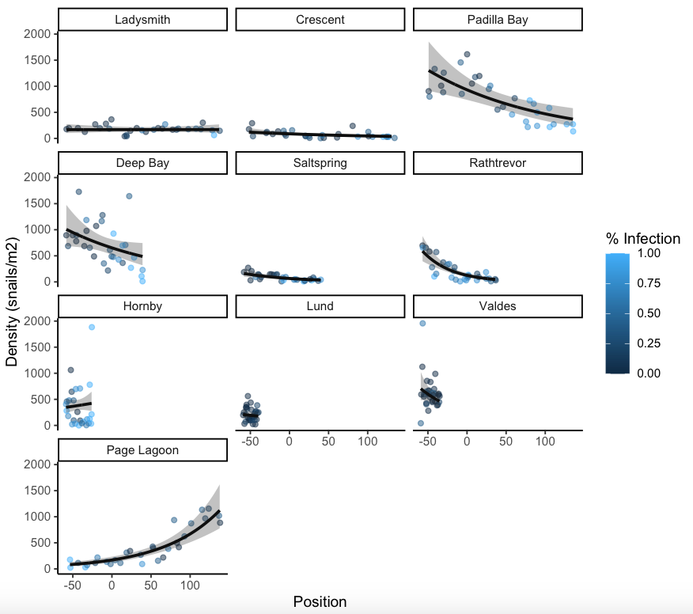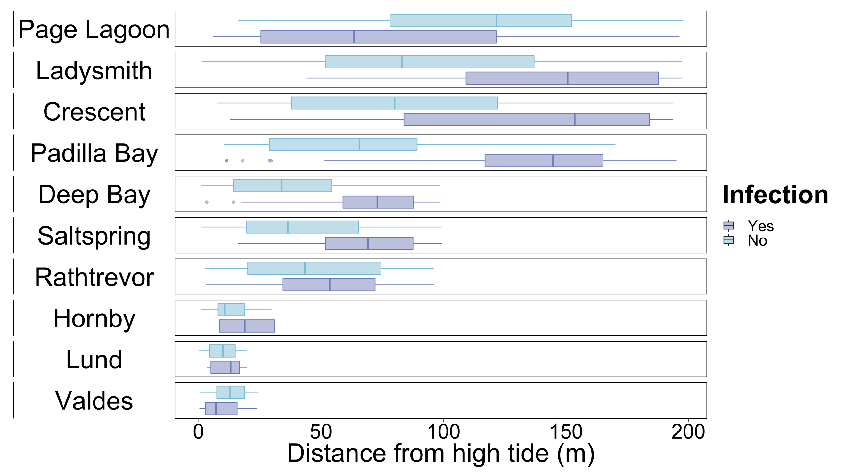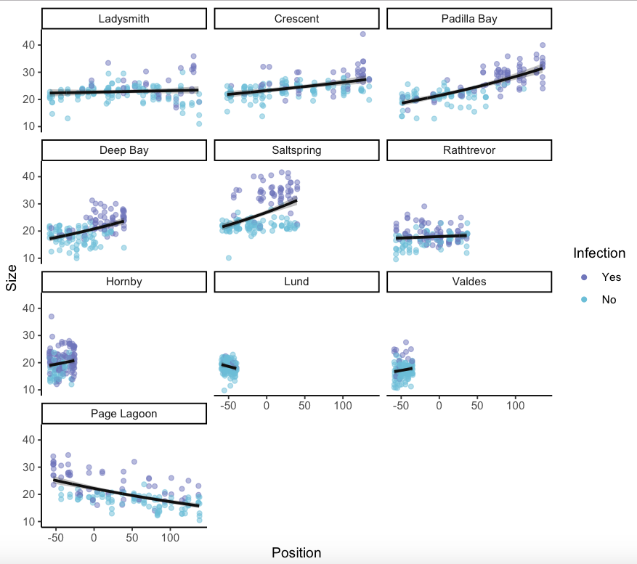



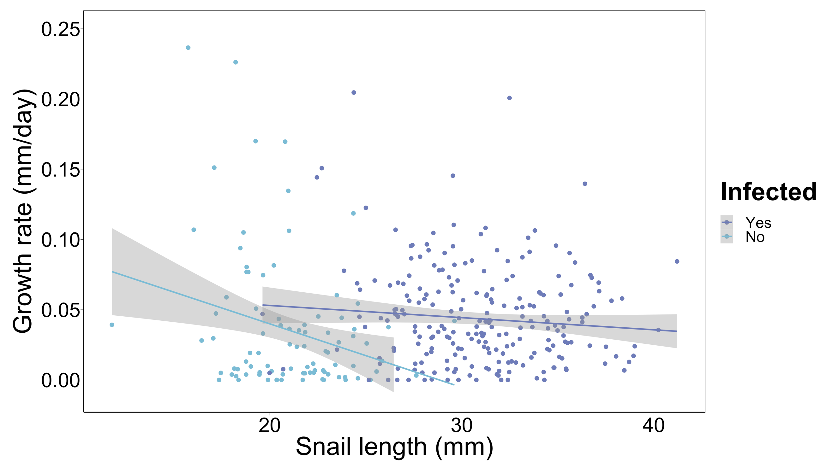

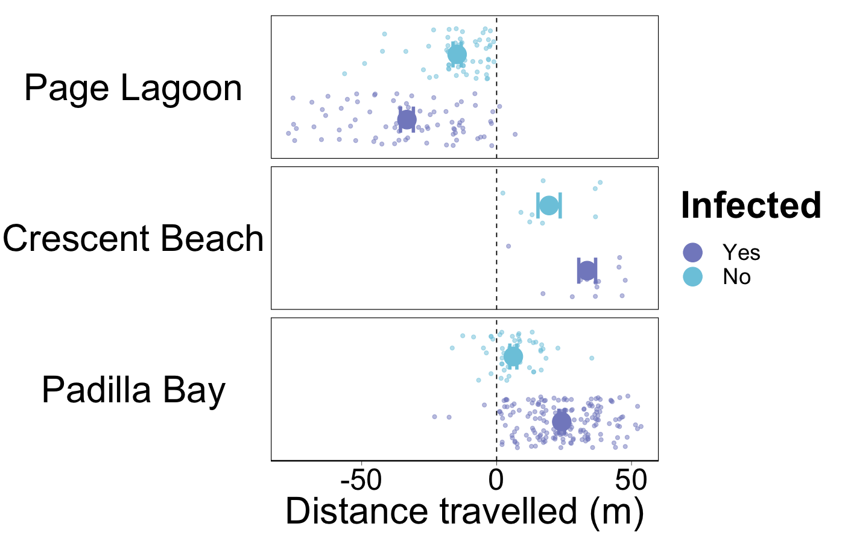

**Discussion**

In general, we found

**References**

Barrett EM. 1963. Fish Bulletin 123. The California Oyster Industry.

Byers JE, Goldwasser L. 2001. Exposing the Mechanism and Timing of Impact of Nonindigenous Species on Native Species. *Ecology* 82:1330–1343. DOI: 10.2307/2679993.

Goedknegt MA, Feis ME, Wegner KM, Luttikhuizen PC, Buschbaum C, Camphuysen K (C. J), van der Meer J, Thieltges DW. 2016. Parasites and marine invasions: Ecological and evolutionary perspectives. *Journal of Sea Research* 113:11–27. DOI: 10.1016/j.seares.2015.12.003.

Holway DA, Suarez AV. 1999. Animal behavior: an essential component of invasion biology. *Trends in Ecology & Evolution* 14:328–330. DOI: 10.1016/S0169-5347(99)01636-5.

Meyer AL, Dierking J. 2011. Elevated size and body condition and altered feeding ecology of the grouper Cephalopholis argus in non-native habitats. *Marine Ecology Progress Series* 439:203–212. DOI: 10.3354/meps09338.

Miura O, Chiba S. 2007. Effects of trematode double infection on the shell size and distribution of snail hosts. *Parasitology International* 56:19–22. DOI: 10.1016/j.parint.2006.10.002.

Miura O, Kuris AM, Torchin ME, Hechinger RF, Chiba S. 2006a. Parasites alter host phenotype and may create a new ecological niche for snail hosts. *Proceedings of the Royal Society B: Biological Sciences* 273:1323–1328. DOI: 10.1098/rspb.2005.3451.

Miura O, Torchin ME, Kuris AM, Hechinger RF, Chiba S. 2006b. Introduced Cryptic Species of Parasites Exhibit Different Invasion Pathways. *Proceedings of the National Academy of Sciences of the United States of America* 103:19818–19823.

Mouritsen KN. 2002. The parasite-induced surfacing behaviour in the cockle Austrovenus stutchburyi: a test of an alternative hypothesis and identification of potential mechanisms. *Parasitology* 124:521–528. DOI: 10.1017/S0031182002001427.

Mouritsen KN. 2004. Intertidal facilitation and indirect effects: causes and consequences of crawling in the New Zealand cockle. *Marine Ecology Progress Series* 271:207–220. DOI: 10.3354/meps271207.

Poulin R. 2010. Chapter 5 - Parasite Manipulation of Host Behavior: An Update and Frequently Asked Questions. In: Brockmann HJ, Roper TJ, Naguib M, Wynne-Edwards KE, Mitani JC, Simmons LW eds. *Advances in the Study of Behavior*. Academic Press, 151–186. DOI: 10.1016/S0065-3454(10)41005-0.

Ross KG, Vargo EL, Keller L. 1996. Social evolution in a new environment: the case of introduced fire ants. *Proceedings of the National Academy of Sciences* 93:3021–3025. DOI: 10.1073/pnas.93.7.3021.

Suarez AV, Tsutsui ND, Holway DA, Case TJ. 1999. Behavioral and Genetic Differentiation Between Native and Introduced Populations of the Argentine Ant. *Biological Invasions* 1:43–53. DOI: 10.1023/A:1010038413690.

Torchin ME, Byers JE, Huspeni TC. 2005. Differential Parasitism of Native and Introduced Snails: Replacement of a Parasite Fauna. *Biological Invasions* 7:885–894. DOI: 10.1007/s10530-004-2967-6.

Wonham MJ, O’Connor M, Harley CDG. 2005. Positive effects of a dominant invader on introduced and native mudflat species. *Marine Ecology Progress Series* 289:109–116. DOI: 10.3354/meps289109.

Zukl M, Simmons LW, Cupp L. 1993. Calling characteristics of parasitized and unparasitized populations of the field cricket Teleogryllus oceanicus. *Behavioral Ecology and Sociobiology* 33:339–343. DOI: 10.1007/BF00172933.